TEST PAPER 1
Ime in priimek:___________________________________
Vsebina: word order in questions, present simple, present continuous, relative clauses writing, verb form, body, personal adjective, listening

Points: 77/_______ Mark:______________

0 – 50% | 51 – 64% | 65 – 77% | 78 - 89% | 90 – 100%
GRAMMAR
- Put the verbs. _______/21
This ___________________ (happen) a few years ago. When I _____________ (come) to school, the lesson ____________________ (already start). At first I _______________(think) I __________________ (oversleep), but it __________________ (be) five minutes to eight. Then I suddenly _________________ (remember). The teacher _________________ (tell) us the day before that the following day the classes ____________________ (start) at half past seven. And I _______________________(forget) again. But I _______________ (learn) my lesson that day. Since then I __________________ (not be) late again. I ____________(work) as a bank clerk for two years now and punctuality ___________________ (be) important in my profession.
Why is the door opened?
Oh, I ___________________ (forget) ____________________ (lock) it.
You always _________________ (keep) them open. One day we _____________ (attack)
in our own living room! If you ________________ (not start) ________________ (think)
about other things than your computer, I _________________ (lock) it in the cellar.

- Relative Clauses. _______/6
1. A waiter is the person _________ serves your food.
2. These are the instructions __________ you use for cooking a particular dish.
3. Do you have the money ___________ I gave you yesterday?
4. This is _________ I lived as a child.
5. Is she the one _________ you don't like?
6. This is ________ we first met.
- Translation. ________/6
On _______________ under_________________ next to ___________________
In________________ behind _______________ in the middle ________________

- Ask for the underline words. _______/4
The best skier in the world, the Austrian Marcel Hirscher._____________________________
The repairman worked on the computer yesterday.__________________________________
There was 20 people at the party.________________________________________________
He studies medicine.__________________________________________________________
- Translation. _______/8
 | nephew |  | quiet
 | sister in law |  | prsti na nogah
 | wife |  | neck
 | lazy |  | foot

- Explain. _______/3
Laptops _____________________________________________________________________
Friends _____________________________________________________________________
Winter _____________________________________________________________________
- Describing pictures. ________/4
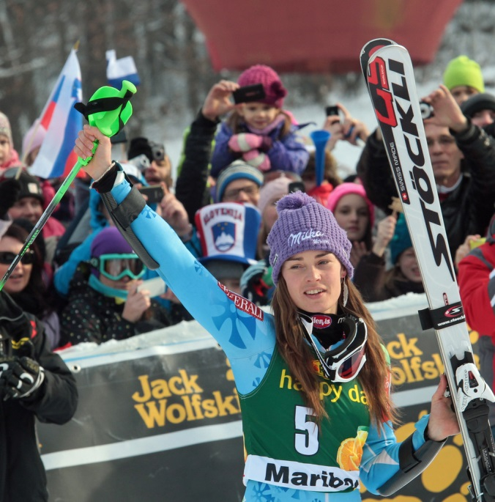

- At the Moulin Rouge. ________/6

- The poster created ______________________.
- Moulin Rouge dance ____________________.
- Describe the Toulouse Lautrec.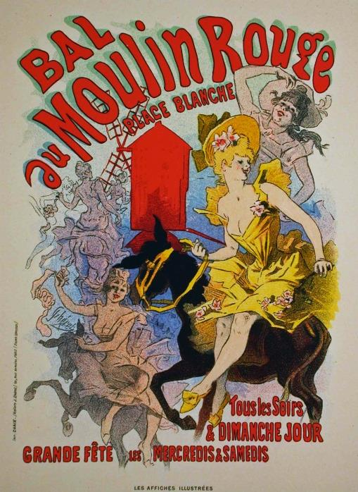

- WRITING
Write about yourself. Inserted in the text only what we are told in unit who's is who.

SLOVNICA: 4t/______ BESEDIŠČE:4t/______ VSEBINA: 5t/____ ________/13

- Irregular verbs. _______/6
SL. PEVOD | BASE FORM | PAST TENSE | PAST PARTICIPLE
vreči
 |  | wore
 |  | rang
 | shut
 |  |  | stolen
poznati

