PREVERJANJE ZNANJA IZ ANGLEŠČINE

Vsebina: past simple, holidays, past continuous, pop music

Datum:

Ime in priimek:________________________________

Točke:

Write negative sentences. ____/3
He studien in Japan. (not Korea)
_________________________________________________________________
My mum enjoyed the book. (not the film)
________________________________________________________________
You were late. (not on time)
________________________________________________________________
Write the past simple of these verbs in the correct column. ____/4
Regular:
Irregular:
Read the text. Complete the question. _____/3
Ten years ago, went to the USA with my parents. We flew to San Francisco, rented a car, and then drove to Arizona to visit the Grand Canyon, and then Las Vegas and Los Angeles. We had a fantastic time! We didn't kniw each other very well at the time, but we got on very well. We were together for 24 hours a day for ten days, but we only argued once – when we got lost! We got marries after that, and are still together.
Where ___________________________________? San Francisco.
______________________________________there? Ten years ago.
________________________________ a good time? Yes, they did.

Definitions _____/4
camp site _______________________________________________________
guesthouse __________________________________________________________
chalet ____________________________________________________________
youth hostel ____________________________________________________

Answer the following questions. _____/4
Why do people need holidays?

Where do they stay?

What do people do on holidays?

How do they travel?

Complete the sentences. _____/3
I ___________________(sleep) on my friend's sofa when his mother came home.
What ___________________(you/talk) about when i came in?
I'm sorry _________________(you/watch) that programme?

Complete the sentences. _____/3
We'll meet you ____ the bus stop.
Let's meet next Saturday ____3.00
Computers were invented ____ the 20th century.

Translate. _____/2
Saw Sue in town yesterday, but she doesn't see me. She looking the other way.
____________________________________________________________
Answer the questions. _____/7

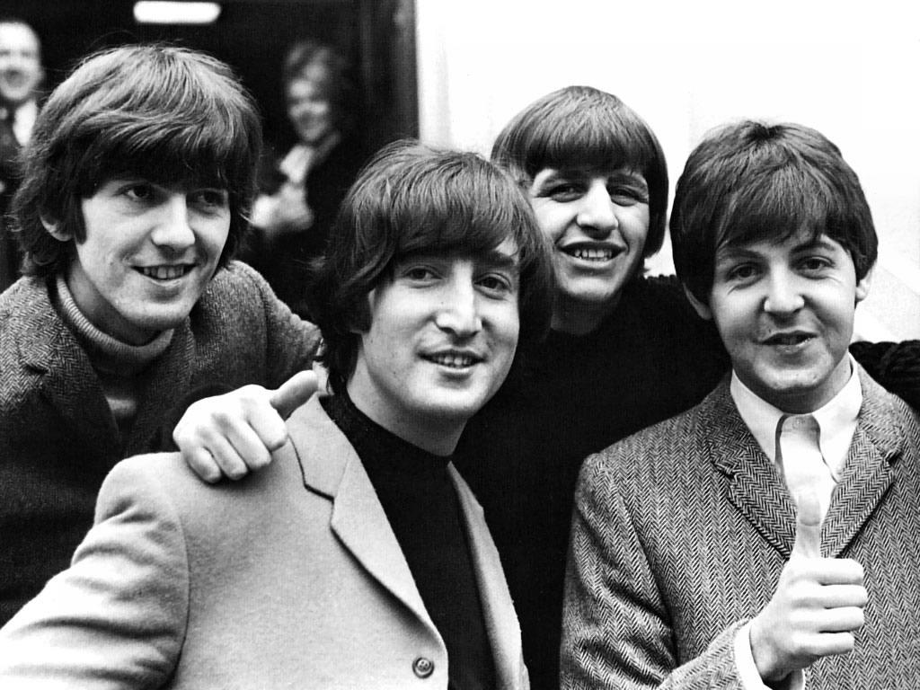Who is the picture?

A song that we listened to

Correct/False
Yoko Ono wrote Imagine.

How important is music in your life?

When do you listen to music?

How important is lyrics?

Slovenian musician whose songs are suitable for learning ______________________

Translate. ____/8
go abroad_______________ go camping ________________________
go sightseeing _________________ go out the night _______________________
windy ___________________ foggy ______________________
adverb __________________ noun ______________________

Irregular verbs _____/3
fall
grow
shut
slovenski prevod past simple past participle

