PIRAMIDE

PRAVILNA 3-STRANA PIRAMIDA

|  |
| --- |
|  |



*UPORABA PITAGOROVEGA IZREKA V PRAVILNI 3-STRANI PIRAMIDI* ENAKOROBNA 3-STRANA PIRAMIDA

|  |  |  |
| --- | --- | --- |
|  |  |  |

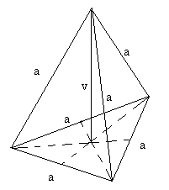

|  |  |  |
| --- | --- | --- |
|  |  |  |

**PRAVILNA 4-STRANA PIRAMIDA**

|  |
| --- |
|  |



P= a2 + 2av1

**O =** a2

## UPORABA PITAGOROVEGA IZREKA V PRAVILNI 4-STRANI PIRAMIDI ENAKOROBA 4-STRANA PIRAMIDA

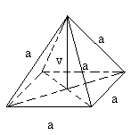

|  |  |  |
| --- | --- | --- |
|  |  |  |



|  |  |  |
| --- | --- | --- |
|  |  |  |

**PRIZME**

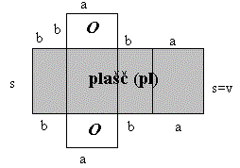

ENAKOSTRANIČNI TRIKOTNIK

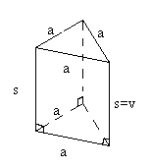

ENAKOKRAKI TRIKOTNIK

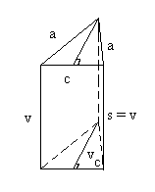

## pl = 3.a.v



PRAVOKOTNI TRIKOTNIK o = **2.a + c** pl **= (2.a + c).**

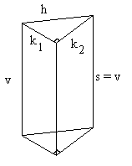

**PRAVILNA ŠTIRISTRANA PRIZMA**

o = k1 + k2 + h pl = (k1 + k2 + h).v O = a2 P = 2.a2 + 4.a.v

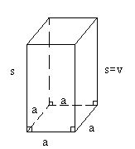

V = a2 . v

**o** = 4.a  **pl** = 4.a.v

ROMB

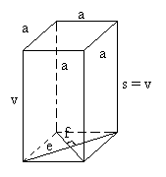

**TRAPEZ**

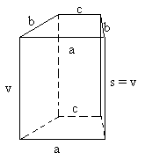

**o** = a + 2.b + c **pl** = 4.a.v



**pl** = 4.a.v

STOŽEC

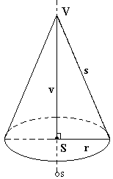

**O= r2**

**P=r.(r + s)**

***pl = r.s***



ENAKOSTRANIČNI STOŽEC

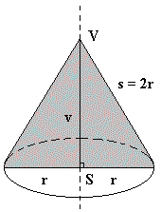

**pl = r2**



P = 3..r2 O= r2