FORMULE ZA PRIZME

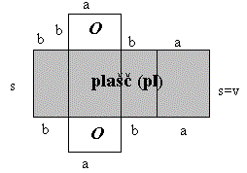

P = 2.*O* + pl

pl = o.v

V = *O*.v

|  |
| --- |
|  |

ENAKOSTRANIČNI TRIKOTNIK



**o** = 3.a **pl** = 3.a.v

|  |
| --- |
|  |

PRAVOKOTNI TRIKOTNIK



o = k1 + k2 + h pl = (k1 + k2 + h).v

|  |
| --- |
|  |

ENAKOKRAKI TRIKOTNIK



o = 2.a + c pl  = (2.a + c).v

|  |
| --- |
|  |

**PRAVILNA ŠTIRISTRANA PRIZMA**

**O** = a2 **P =** 2.a2 + 4.a.v

**V** = a2 . v

**o** = 4.a  **pl** = 4.a.v

|  |
| --- |
|  |

**ROMB**



**o** = a + 2.b + c **pl** = 4.a.v

|  |
| --- |
|  |

**TRAPEZ**



**o** = 4.a **pl** = 4.a.v

|  |
| --- |
|  |

**PRAVILNA ŠESTSTRANA PRIZMA**



**o** = 6.a **pl =** 6.a.v

**DIAGONALE**

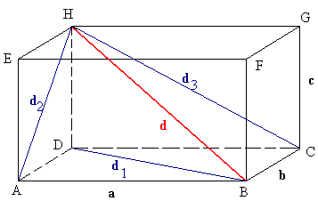

**d12 = a2 + b2**

**d22 = b2 + c2**

**d32 = a2 + c2**

**d2 = a2 + b2 + c2**

**DIAGONALNI PRESEK**

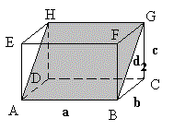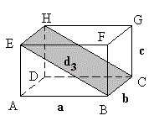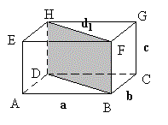

ploščina preseka = a.d2 ploščina preseka = b.d3 ploščina preseka = c.d1